Electricity Market Design Reform – Regulation (EU) 2024/1747 of the European Parliament and of the Council of 13 June 2024 & Directive (EU) 2024/1711 of the European Parliament and of the Council of 13 June 2024

Context:
The Electricity Market Design (EMD) Reform was adopted as a response to the energy crisis traversed by the Union in 2022. Despite the significant share of renewables across the continent, the functioning of the EMD, i.e., basing the price of power on the costs of fossil fuels (especially gas), led to spikes in prices for the final consumer, destabilizing the functioning of the market. Thus, the amended provisions of the Regulation and Directive that entered into force on July 16th, 2024 aim to provide an in-depth reform to the EMD, including the rules governing grid infrastructure and integration to facilitate the uptake of renewables.
Calendar:
- 20 days after the publication in the Official Journal: Entry into force (EIF) of the Regulation: the provisions on contracts for difference (CfDs) and power purchase agreements (PPAs)
  - EIF + 9 months – ENTSO + EU DSO joint methodology
  - EIF + 12 months – ACER methodology approval/amendment
  - EIF + 24 months – NRA report
  - EIF + 30 months – indicative national objective for non-fossil flexibility
Regulation revision: June 30th, 2026
- 6 months after EIF of the Directive (January 17th, 2025): transposal of the flexible grid connection agreements
- 24 months after EIF of the Directive (July 17th 2026): transposal of the energy sharing provisions

Regulation (EU) 2024/1747 of the European Parliament and of the Council of 13 June 2024
- Grid development, tariff methodologies and anticipatory investments – Article 18
It is undoubtable that grids and energy networks are the backbone of the national, regional, and European markets and the key enablers of the green energy transition. At the same time, however, they are also the main bottleneck that hampers the process due to the traditionally centralized development model that faces hardships in integrating renewable energy sources (RES). For this reason, to end the dependency on Russian fossil fuels and to achieve 42.5% RES by 2030 assumed through the REPowerEU plan, the Union must undertake the necessary measures to strengthen the energy infrastructure.
Following the desideratum of reliability, Article 18 of the Regulation introduces a series of changes to the tariff methodology aimed at supporting the network expansion, which, as per the new provisions, shall:
- Reflect the fixed costs of the TSOs and DSOs (i.e., the costs related to construction, maintenance, operation and administration of the transmission and distribution systems)
- Incentivize efficiency, anticipatory investments and grid optimization
- Foster market and RES integration
- Facilitate energy storage, demand response and related research activities
- Contribute to the NECP objectives and promote public acceptance
- Facilitate innovation and develop the necessary infrastructure to reach the minimum interconnection target for 2030
- Recognize all relevant costs as eligible, including the ones related to the anticipatory investments (such costs can include the expenses related to future-proofing the network, like infrastructure upgrade to integrate RES, capital expenditures, operational expenditures, innovation and efficiency improvements, etc.)
In essence, the tariff methodology shall be cost-reflective, transparent and non-discriminatory, taking also into account the need for network security and flexibility.
While the amendments to the tariff methodologies are relevant, perhaps the most important aspect of Article 18 pertains to the anticipatory investments, i.e., reinforcement based on anticipated potential future needs, which go beyond the confirmed generation and demand. The scarcity of grid capacity has been observed in the blockages that many countries face (including Spain, Italy, France, Germany, and Romania, among others), leading to significant connection delays, which push back further the decarbonization of not only the energy sector but also the connected ones such as heating and cooling, transport and industry. In the context in which the regulatory framework does not incentivize the DSOs to proactively address the challenges that may arise, preventing thus what could wrongfully be perceived as excessive investments, it is undoubtable that the business-as-usual model will always fall short of delivering the necessary services to all sectors that rely on energy. Therefore, a forward-thinking approach is fundamental, especially in an increasingly decentralized and granular supply and demand.
Strengthening the provisions on anticipatory investments, the Commission will, as per the EU Action plan for Grids, propose, by O1 of 2025, “guiding principles identifying conditions under which anticipatory investments in grid projects should be granted,” which will create the necessary regulatory preconditions for forward-looking grid build-out.
- Contracts for Difference (CfD) – Article 19d
CfDs are perhaps one of the most important mechanisms for incentivizing investment in renewable energy sources (RES) and low-carbon projects, as they protect from the volatility of the wholesale electricity markets through long-term revenue security. For solar, which has the lowest levelized cost of electricity (LCOE) among RES but high capital expenditures (CAPEX), this instrument is highly relevant as a risk management tool through predictability.
When it comes to direct price support schemes for new power-generating facilities (as per 19d (4): wind, solar, geothermal, hydropower without reservoir, nuclear), Article 19d of the Regulation states that mechanism should take the form of two-way CfDs or of equivalent schemes with the same effect, providing a set of design criteria as follows:
- Voluntary participation
- Preservation of the incentives to operate and participate efficiently in electricity markets and market circumstances (i.e., the schemes – CfD or equivalent – should not discourage the optimization of the operations based on market signals)
- Prevention of any distortive effect of the support schemes on operation, dispatch, and maintenance decisions of the renewable asset (the schemes should not negatively impact the decision on how to operate efficiently and maintain the assets)
- Preservation of the market competition by aligning the remuneration to the cost of the new facility while avoiding overcompensation (fair cost compensation, but not to the extent that the level playing field in the internal market is distorted)
- Inclusion of penalty clauses in case of unilateral early termination of the contract (in case one party ends the contract early without mutual agreement, they would face penalties, providing thus a disincentive for premature contract termination and adding stability to the agreement).
In essence, with the EMD reform, two-way CfDs or equivalent schemes that have the same effects are mandatory when public funding is involved in direct price support, and will be subject to the Commission’s assessment under existing state aid rules, independent of technology, to avoid any competition distortion. Small-scale RES installations can, however, be exempted from this requirement.
When it comes to storage or other aspects directly related to electricity generation, and which do not use direct price support, such as investment aid in the form of upfront grants, tax measures or green certificates amongst others, the obligation to use two-way CfDs or equivalent schemes does not apply.
While CfDs, as a hedging tool, are advantageous for all the parties, they can also pose significant risks if not designed and implemented properly. In essence, it is fundamental to ensure that this type of instrument remains market-based, voluntary and balanced.
- Power purchase agreements (PPAs) – Article 19a
Aside from the provisions on CfDs, the EMD introduces measures to promote using PPAs as long-term tools to guarantee price stability to suppliers and consumers. In this sense, the Regulation urges the Member States to create the proper market conditions by removing unjustified barriers and/or discriminatory procedures of charges, to provide long-term predictability. As in the case of the CfDs, PPAs are highly important for RES projects, as they both lower the revenue risks and function as an insurance mechanism to secure investment.
In this respect, the Regulation states that Member States should:
- Promote the uptake of PPAs
- Remove the unjustified barriers and disproportionate or discriminatory procedures or charges to provide price predictability and reach the objectives set in their NECPs, preserving, at the same time, the market competitiveness and liquidity
- Ensure that instruments (such as state-backed guarantee schemes at market prices, private guarantees, and facilities pooling demand for PPAs) to mitigate the financial risks linked to defaults in payment by off-takers within PPAs are in place and readily available to customers that face barriers to enter to the PPA market
- Ensure that state-backed guarantee schemes for PPAs do not lower the liquidity in the electricity market and do not support power generation from fossil fuels. In this respect, these guarantees can be limited to exclusive support for the purchase of electricity from RES.
Under the amended Regulation, RES support schemes should allow the participation of projects that reserve part of the electricity for sale through a PPA (only if it does not affect the market competition). When it comes to the design of such schemes, bidders should be incentivized to facilitate the access of customers who face entry barriers to the PPA market (if it does not affect the market competition).
The Commission will assess the viability of one of the EU market platforms to be used voluntarily, including the pooling of demand for PPAs through aggregation. Furthermore, ACER will evaluate, by October 17th, 2024, the need to develop and issue voluntary templates for PPAs, adapted to the needs of the different counterparties.

- Assessment of flexibility needs, indicative national objective for non-fossil flexibility, support schemes and design principles – Article 19e, 19f, 19g, 19h
Aside from the aspects of PPAs and CfDs, the Regulation introduces provisions on the RES integration flexibility needs. As balance has traditionally been achieved through power generation adjustment, distributed energy resources (DER) can pose potential challenges to the grid due to its historically centralized development nature. Currently, in times of high electricity demand, fossil-fuel peaker plants (gas and coal) are dispatched to manage the supply-demand balance, an option that is not only expensive to build and operate but also damaging to the environment and very costly. However, while the system is not – yet -fully adjusted to the uptake of intermittent resources, DERs can be part of the solution, supporting the shift toward decarbonization and electrification. For this reason, the Regulation introduces a series of amendments aimed at bolstering the non-fossil flexibility through demand response and energy storage, among others. As such, the national regulatory authority (NRA or any similar entity) is required to elaborate and adopt reports, based on the analyses provided by the TSOs and DSOs, for the next 5-10 years that must:
- Evaluate the different types of flexibility needs, at least on a seasonal, daily, hourly basis, to integrate electricity generated from RES
- Consider the potential of non-fossil flexibility resources such as demand response and energy storage, including aggregation and interconnection, to fulfill the flexibility needs at the transmission and distribution levels
- Identify the barriers and propose relevant mitigation measures, including the removal of the regulatory blockages
- Consider the flexibility sources expected to be available in other Member States.
As anteriorly mentioned, whereas the NRAs are responsible for elaborating the reports, the TSOs and DSOs will be providing the data. In this respect, the ENTSO for Electricity and the EU DSO entity will coordinate their works, defining the type of information to be transmitted and its format and developing the analysis methodology, ensuring that:
- All flexibility sources are included in a cost-efficient manner
- The planned investment in interconnection and flexibility at the transmission and distribution levels are taken into account
- The decarbonization needs of the electricity system are accounted for
On the calendar, the ENTSO and EU DSO have nine months (April 17th, 2025) to jointly submit the methodology to ACER, which has until July 17th, 2025, to approve it or amend it. No later than one year after its adoption and every two years thereafter, the NRAs must adopt the report on the flexibility needs. Six months after its submission, every Member State must define an indicative national objective for non-fossil flexibility.
- EIF + 9 months (Apr. 2025) – ENTSO + EU DSO joint methodology
- EIF + 12 months (July 2025) – ACER methodology approval/amendment
- EIF + 24 months (July 2026) – NRA report
- EIF + 30 months (Jan. 2027) – indicative national objective for non-fossil flexibility
Where the non-fossil flexibility investments are insufficient for achieving the indicative national objectives, Member States have the option to implement support schemes, following a criteria set:
- Proportionality (not to go beyond what is necessary to achieve the targets)
- Non-fossil flexibility (limited only to new investments in non-fossil flexibility such as demand side response or energy storage)
- Locationality and optimality (the investments must be in optimal locations)
- Not implying starting fossil fuel-based generation located behind the metering point (non-fossil flexibility support schemes should not inadvertently encourage the use of fossil fuel-based generation behind the meter)
- Transparency, competitiveness, voluntary, non-discriminatory, and cost-effectiveness of the selection process
- Distortion prevention and preserving efficient operation incentives, price signals, and exposure to price variation and market risks.
- Electricity market integration incentives
- Minimum participation level, taking into account the technical specificities of the asset, delivering the flexibility and appropriate penalties in case of not respecting it, as well as in case of not following efficient operation incentives and price signals
- Encouraging participation across borders is beneficial when the cost-benefit analysis shows positive results.
The amended regulation introduces new responsibilities for the TSOs, which should publish (and update at least monthly) clearly and transparently the information on the capacity available for new connections, with high spatial granularity, the capacity under connection request (updated regularly in terms of status and treatment) and the possibility of flexible connection in congested areas.
V. Regulation amendment – impact on Romania
The new amendments to the Regulation, which are binding in their entirety and directly applicable to all Member States, establish the necessary preconditions for our country to create a functioning market for PPAs and CfDs, which is currently lacking. On the one hand, we expect an uptake in the number of signed PPAs in Romania, following the removal of the unjustified barriers and the future implementation of de-risking instruments. On the other, considering the general criteria listed, it appears that the long-awaited CfD mechanism is on track design-wise, putting – at least until we see the final documentation – the preoccupation regarding the unilateral termination clause at ease.
It is important to note that the Regulation sets a path for financing the assets through a mix of CfDs and PPAs. However, young markets, such as Romania’s, should first focus on the development of a proper environment for each separately to overcomplicate the procedures that could, in turn, inadvertently self-sabotage their success.
Aside from the highly anticipated measures regarding the PPAs and CfDs, the Regulation introduces relevant flexibility provisions, with the most significant aspect for Romania being the non-fossil flexibility. Contrary to the national strategic view, which proposes the development of new gas capacities to balance the intermittent nature of RES, the European approach supports the integration of alternative measures such as storage and demand side response to manage the fluctuations in production and consumption. Furthermore, compared to the general narrative, it is evident that solar, wind and other DERs are not a problem but the solution that supports the tectonic shift in energy production. Through the amended Regulation, it is now clearer than ever that the centralized development model is no longer suitable for the current and future needs of the continent. Overall, the new EMD facilitates the participation of renewables in the wholesale electricity markets by increasing their liquidity and helping support the grid decongestion where needed. Therefore, instead of focusing on a short-sighted perspective, Romania should adopt a forward-thinking viewpoint, encouraging cost-optimal solutions development.
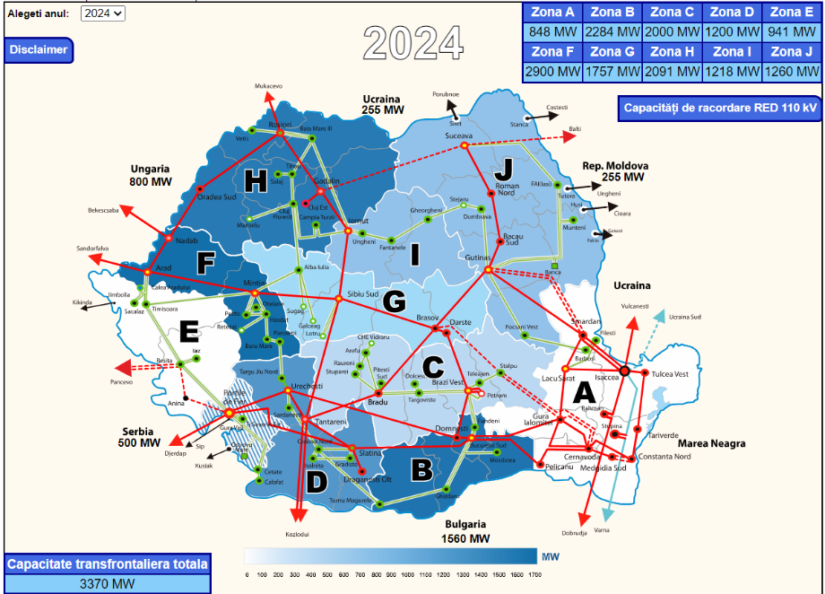
While PPAs, CfDs and assessment of the flexibility needs are highly relevant for uptake of RES, the importance of anticipatory investments cannot be understated. For Romania, a country where the grid capacity is limited due to (1) lack of flexibility, (2) insufficient development and investments, and (3) aging infrastructure, a forward approach is necessary to solve the blockages that lead to long grid connection cues and to ensure that such problems will not be the case in the future.
Source: Transelectrica’s available capacities map
Yet, when it comes to the grid plans, there is a significant misalignment between Transelectrica’s TYNDP, the national targets, and the development rates. To achieve the objectives assumed at the European level, Romania would need to have by 2030, as per the RPIA, RWEA and Deloitte Study and the Commission’s recommendation, a total installed capacity of 11.1 GW of solar (6.1 utility-scale and 5 in prosumers) and 11.5 GW of wind (10.5 on-shore and 1 off-shore), i.e., an addition of 16 GW to the existing operating capacity, which translates to a 44.4% RES share. However, the target set through the (draft) NECP is disappointingly low, envisioning only 8.3 GW for solar (5.8 utility-scale and 2.5 in prosumers) and 7.3 GW of wind (only on-shore), which equate 9 GW of new installed capacity, almost half less than the necessary. Yet, even in the context of the lack of ambition, Transelectrica’s TYNDP fails to accommodate the new capacities that need to be integrated into the grid. As such, by comparing the grid plans to national policy targets, the Romanian TSO’s development plan falls behind the 2030 national targets.
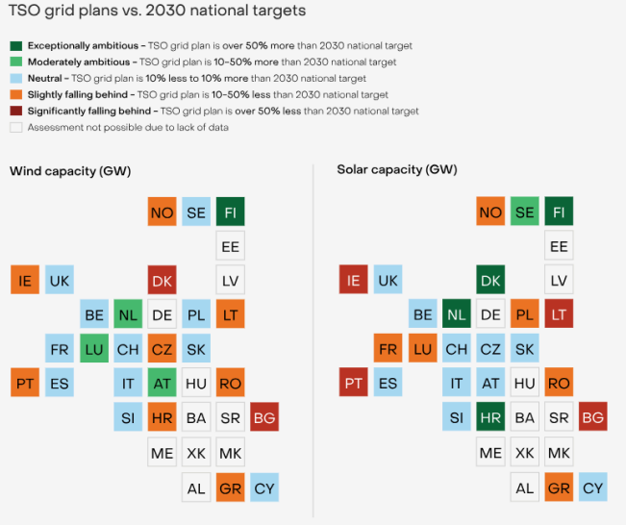
Source: Ember, Putting the mission in transmission: Grids for Europe’s energy transition, 2024
The Romanian RES sector has experienced significant development since the former iteration of Transelectrica’s TYNDP, with the number of solar and wind projects and the national targets increasing. However, clean energy sources continue to be under-considered when it comes to network expansion and reinforcement needs, as evidenced by the lack of concrete actions to support their integration into the grid. This misalignment is further evidenced by the investment proposals, which envision mainly an increase in the interconnection capacity to solve the blockages. In the context in which the grid planning lags behind the level of ambition and the industry’s development speed, Romania should embrace the anticipatory investments as a way to ensure that the future RES projects – which will definitely come – can have the means to connect.

Directive (EU) 2024/1711 of the European Parliament and of the Council of 13 June 2024
Complementing the Regulation amendments, Directive (EU) 2024/1711 introduces a series of important provisions in support of the faster deployment of RES and the final consumers, i.e., flexible connection agreements, the right to energy sharing, protection from disconnections, and access to affordable energy during an electricity price crisis, among others.
- Flexible connection agreements (FCAs) – Article 6a
As grid connection is the main bottleneck for the large-scale deployment of RES projects across the EU, the Directive established the obligation for the NRAs (or other relevant competent authorities) to develop a framework for the TSOs and DSOs to establish FCAs, i.e., agreed conditions for capacity connection that includes conditions to limit and control the injection and withdrawal from the transmission or distribution networks, where the availability is limited or inexistent. As such, it must be ensured that:
- FCAs do not delay the network reinforcements in the identified areas (FCAs are means to make use of the network capacity and not a replacement of the necessary investments)
- The conversion from FCA to firm connection agreements is made once the network is developed (FCAs are a temporary solution that must be replaced, once the necessary works are completed, with a firm connection that ensures the unrestricted ability to export, irrespective of the conditions, the maximum amount of contracted MW)
- FCAs are enabled as a permanent solution, including for storage, where the NRAs deem network development as not efficient
However, for FCAs to work it is necessary that the TSOs and DSOs publish the information comprising the congested areas and the status and the treatment of these connections.
While the NRAs are responsible for the general framework, a criteria set must be included:
- The maximum firm injection and withdrawal of electricity to and from the grid and the additional flexible and withdrawal capacity that can be connected by time blocks throughout the year
- The applicable network charges for firm and flexible injection and withdrawal capacities
- The agreed duration of the FCA and the expected date for granting connection to the entire requested firm capacity
On the side of the system user connecting through a FCA, the Directive establishes the requirement to install a power control system by an authorized certifier.

-unlimited capacity to export the full contracted MW regardless of the conditions

-contain restrictions that pertain to the reliability of the connection points. Generally, there are no other constraints except for the limited security of supply
-contain restrictions or constraints identified in the Connection Agreement, including:
1. the capacity that can be connected & the time
2. export limiting devices
3. active network management schemes

Source: SP Energy Networks, Flexible Connections and principles of Access Policy, 2020; National Grids ESO
- Energy sharing – Article 15a
Aside from the provisions on FCAs, the Directive creates the necessary conditions for natural and legal persons to participate in energy sharing, i.e., the self-consumption by active customers of RES that is generated/stored on sites between them by a facility they own, lease or rent (in whole or in part)/the right to which has been transferred to them by another active customer (sold or for free). In this sense, Member states must ensure that:
- All households, SMEs, public bodies (if the Member States decide so), or other categories of final customers can participate within the same bidding zone
- The TSOs and DSOs monitor, collect, validate and communicate relevant electricity sharing data, providing a contact point to register energy sharing arrangements and offering practical information
- Active customers:
  - can share RES energy between themselves through private agreements or legal entity, with the condition that energy sharing is not their primary commercial/professional activity
  - benefit from all consumer rights and obligations as final consumers and are entitled to subtract the electricity injected into the grid from the their total metered consumption within an interval no longer than the imbalance settlement period, paying the relevant taxes, fees and network charges.
  - are not obliged to comply with supplier obligations if the installed capacity is <10,8 kW (for a single household) and <50 kW for multi-apartment blocks
  - have access to voluntary template contracts with fair and transparent terms and conditions, as well as out-of-court dispute settlement with other participants in the energy sharing agreement in case of conflicts
  - enjoy fair treatment by market participants or their balance responsible parties
When it comes to thresholds, the Directive sets specific targets as follows:
a. single households: 10,8 kW, which can be increased to up to 30 kW
b. multiple-apartment blocks: 50 kW, which can be decreased to 40 kW or increased up to 100 kW
c. SMEs: the installed capacity of the generation facility for the energy sharing scheme: 6 MW

- Access to affordable energy during an electricity price crisis
Rather interesting is the insertion of an article dedicated to access to affordable energy during an electricity price crisis, which is highly relevant especially in the context of the recent events. As per this new provision, the Council can declare a regional or Union-wide electricity price crisis if the wholesale electricity prices are at least two and a half times the average price during the previous five years (excluding the period when an electricity price crisis was declared) and at least 180 EUR/MWh, which is expected to continue for at least six months and sharp increases of at least 70% are expected to continue at least three months.
- Directive amendment – impact on Romania
Complementing the Regulation, the Directive introduces a series of relevant provisions, especially when it comes to grid connection. The possibility of using FCAs as a temporary (or permanent, depending on the relevant assessments) solution may help alleviate the long queues that the RES projects face at the moment in Romania and ease the concerns of the investors who would no longer be bound to the network upgrade. However, for this model to function, it is necessary to ensure that the TSO and DSOs do not see FCAs as permanent solutions where it is not the case.
On the topic of energy sharing, the Directive’s provisions could solve Romania’s issue regarding the lack of a regulatory framework. Whereas in 2022, with the transposal of RED II, a series of provisions were introduced through the government emergency ordinance, the secondary legislation by ANRE continues to be absent. The cause for the lack of operationalization can be attributed to the possible disruptions that such a model could create, which is a response seen in the case of prosumers as well. However, with the new grid connection rules, a revamp of the market is expected, which may create a favorable environment for energy sharing.

